PASIG CITY SCIENCE HIGH SCHOOL

In Partial Fulfillment of
Requirements in Technical
Research I

Cajuguiran, Isabel Katrina G.
Bonifacio, Gianne
Silverio, Romabel
Ventura, Emmanuel
Villanueva, Krizia Nicole

Ms. Donabel G. Simporios
July 2010
CHAPTER I
INTRODUCTION
Mushrooms are fleshy plants that belong to the fungi group. They grow from decaying materials and have no chlorophyll. They usually grow in places where it is cool and moist. They are usually found in pastures, meadows, and woodlands. Some are commercially raised in caves, indoors on shelves filled with partly decaying animal and plant materials, and in greenhouses where the average outside temperature is cool. Mushroom spawn, or root growth, that is planted in this material grows rapidly and soon fills the bed with tiny threadlike rootlets. The mushrooms do not show above the ground until the rootlets are well grown.
Mushrooms come in different colors, usually white, orange, red, and brown. They also have different sizes and shapes, the most common of which have short, thick stems and umbrella like fleshy caps. While quite a few are poisonous, mushrooms are widely cultivated because of its many uses to man, mainly as source of food. Aside from being edible and delicious to eat, these small plant fungi also have medicinal properties because they contain statins like lovastatin, a substance that is used in medicines for cardiovascular patients. Lovastatin is a substance that lowers the cholesterol in the blood.
Moreover, mushrooms can also be used for mycoremidiation – the process of using fungi to return an environment (usually soil) that is contaminated by pollutants to a less contaminated state.
Nutritionally speaking, mushrooms are richer in quality proteins than green plants. It contains important minerals like iron, phosphorus, potassium, and calcium and is rich with vitamins, particularly vitamin D. It is also rich in fibers that stimulate digestion in humans. Thus, mushrooms are considered an “almost perfect food” and very popular around the world.

BACKGROUND OF THE STUDY
Mushrooms have yet to get acceptance and approval of the Filipino palate, especially the children. Although not yet very popular among Filipinos compared to other countries, the demand for mushroom in the country is rapidly increasing primarily because of its excellent medicinal and nutritional value as well as being eco friendly. Thus far, the mushroom business in the Philippines is apparently a burgeoning business with enormous commercial potential in as much as it targets a basic need: food. There is also a claim, on the contrary, that its present cultivation in this country is limited, perhaps due to the limited local knowledge about its culture. Because of this, the Department of Agriculture (DA) is actually calling on farmers in Pampanga to explore the possibilities of venturing into mushroom production as an extra source of income. Mushroom production in the Philippines is a lucrative agribusiness venture that needs minimal capital input and provides high return on investment, since farmers can use a large volume of agricultural waste products such as rice straws, sugarcane bagasse, banana leaves, water lilies, corn stalks and corn cobs, to be converted into beneficial agricultural inputs in producing mushroom. It is likewise an untapped market among health conscious consumers and in the booming health products industry.
However, most use sawdust in cultivating mushrooms. The use of sawdust means the cutting of trees to be used for building materials. Since mushrooms can be grown in partly decaying animal and plant materials, it would be more prudent and eco-friendly to use agricultural by-products.
This research will try to study the effects of growing mushrooms, such as the Oyster Mushroom as a source of spawn for cultivation, using coffee brands as the agricultural “waste product” (decaying plant material), as an alternative to using sawdust.
Oyster Mushroom, or Pleurotus ostreatus, is an edible mushroom that is readily available in most supermarkets. Coffee on the other hand, brings a host of nutrients to the ground such as magnesium, calcium and nitrogen thus the plants benefit very highly from the use of grounds. It also adds tremendous acidity to the soil. Certain plants thrive on soil acidity such as blueberries, rhododendrons, roses, hydrangeas, and gardenias. On other plants, you may need to add the grounds to grass or leaves in mulch form, as those will assist to neutralize the acid in the coffee.
Other direct benefits include making the soil much easier to till, and worms seem singularly attracted to the grounds.

OBJECTIVES
- The study aims to make a substrate containing Coconut husk, shredded newspaper and coffee grounds
- To know if coffee grounds and newspaper as additives to the substrate would affect the number of spawn
- To know if the new substrate will produce larger mushrooms
- To know the effectiveness of the substrate by measuring the time of growth of the mushrooms
- To compare the quality of growth of the mushroom grown on the new substrate with the quality of growth of the mushroom grown on “normal” substrate

HYPOTHESIS
Used coffee grounds, shredded newspaper, and coconut husk contain the nutrients needed by the oyster mushroom to grow, thus they can be considered as substrate for said mushroom instead of sawdust.

SCOPE AND LIMITATIONS
Food shortage has become a concern both by government and science vis-à-vis the rapidly growing population. With the fast rising population growth and the limited natural resources, science and technology need to find alternatives for faster and more efficient food production.
The Pleurotus Ostreatus mushroom is among the food source that can be easily cultivated in large quantities and available in a short period of time. It contains nutrients comparable to meat, making mushroom a good alternative source of food instead of the more expensive meat.

This research study will deal with oyster mushroom that belongs to the species Pleurotus ostreatus only. The Musa paradisiaca Linn.banana peeling will be utilized for its substrate. This material will be sourced from the wastes of banana cue and turon vendors at the Pasig Market. Further, it the study will deal only with the possibility of growing oyster mushroom in the substrate of the Saba peelings. The determinants would be the quantity, color, shape and size of the produce. The team, however, will not study whether the mushrooms’ nutritional value will be affected by the substrates or the length of time in the growth of the mushroom.

The study shall be conducted in Pasig City Science High School. The Coffee grounds will be sourced from Starbucks Coffee.

SIGNIFICANCE OF THE STUDY

The experiment may be able to address both the societal issues of waste reduction and food shortage. As the banana is one of the Philippines’ major source of food, its peeling has become one of the most plentiful in the biodegradable wastes. Its utilization can significantly reduce trash found in the public markets of Pasig City.
On the other hand, food shortage can now be addressed. The oyster mushroom is harvestable in a few weeks thus making it available to consumers in a shorter period of time. Planting the fungi is simple. The mushrooms can be planted in any place where there is ample ventilation and shade. Food production can thus be increased right within the comfort of one’s home. Since the time frame for harvesting mushrooms is short, the demand for the fungi can be addressed.
Food cost can be reduced because Saba peeling is a waste material, making the cost of planting or growing mushroom less expensive. When overhead costs are reduced, mushroom farmers can sell their goods at a lower price. With farm gate prices lowered, the direct result should be great savings for the ordinary consumer.

REVIEW OF RELATED LITERATURE
A. Newspaper
Newspaper is printed on thin paper made from a combination of recycled matter and wood pulp, and is not intended to last very long. By 2007, there were 6580 daily newspapers in the world selling 395 million copies a day. A newspaper is a regularly scheduled publication containing news, information, and advertising. It contains information about the latest happenings locally and globally. It also contains advertisement by companies, latest movies to come in the wide screen and products sold. It also has the entertainment section where the latest news on the field of entertainment is written including the latest happenings in the life of your favorite stars. It may also contain obituaries for those who died and the sports section for the latest and updated news regarding your favorite player or team.
The chemical composition of newspaper depends on the type or grade of paper. Typically most grades of paper consist of organic and inorganic material. Organic portion consisting of cellulose, hemi-cellulose, lignin and or various compound of lignin (Na-lignate, etc.) May be 70 to 100%. Inorganic portion consisting of mainly filling and loading material such as calcium carbonate, clay, titanium oxide, etc may be 0 - 30% of paper.
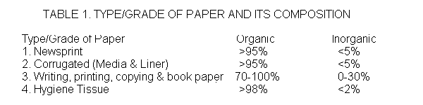

B. Coffee Grounds
Coffee ground is easily available. Because almost everyone is drinking daily a cup of coffee, then we'll have a fabulous source of organic matter right away. After brewing coffee, coffee grounds are often tossed into the trash bin. Some people regard the group of squeezed coffee beans as worthless items. If they only knew that coffee grounds can be a good substrate, they would probably store the used beans in their cupboards.
Best of all, the use of coffee grounds is environment-friendly. You better think twice if you plan to throw away your next batch of coffee grounds. Coffee grounds are a "green," meaning an item that is rich in nitrogen. Coffee grounds are approximately 1.45% nitrogen. They also contain magnesium, calcium, potassium, and other trace minerals. Used coffee grounds are a common additive to nitrogen deficient substrates. Some commercial growers even grow purely on a coffee based substrate. When supplementing another substrate, coffee grounds are often added
At 15-20% by volume.

C. Coconut Husk
Coconut husks are made of bristle fiber (10%), mattress fiber (20%) and coir dust and shorts or wastes (70%). The abundance of fiber makes it good, stable supply for cottage industries that make brushes, doormats, carpets, bags, ropes, yarn fishing nets, and mattresses, etc.
Coconut husk are a renewable, biological and durable, large-scale natural resource. The popularity of coconut husk is due to its excellent characteristics: very good and versatile cultivation tool, water is better retained: can absorb up to 8 times its volume in water – up to 50% less watering maintenance, high aeration: optimal root growth is facilitated, perfect drainage: spreads water throughout the substrate, excellent bio-stability: coconut husk remains stable for more than 8 years, and because it has a natural rooting hormone as well as anti-fungal properties.

D. Oyster Mushroom
Oyster mushrooms or Pleurotus ostreatus are edible fungi. They are mostly white and fleshy and are usually found on living or dead plant life. Other varieties have light shades of brown, beige or tan. These organisms are indigenous in the Philippines and other tropical Asian countries. The mushroom has a cap about 5–25cm in diameter. It is shaped like a fan or an oyster, from which it got its common name. Flesh white, firm, varies in thickness due to stipe arrangement. The gills of the mushroom are white to cream, descend stalk if present. If so, stipe off-center with lateral attach to wood. The spore print of the mushroom has shades of white to lilac-gray and is best viewed with a dark background. The mushroom’s stipe is often absent. When present it is short and thick. The mushroom’s taste is described as mild with a mild odor of anise.

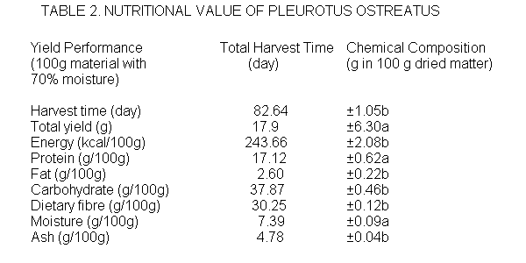

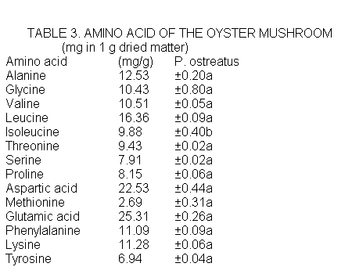
The Oyster mushroom does not require much from its substrates, except that it should be devoid of any organisms even before the substrate material is pasteurized. With any growth, the mushrooms will not live. The substrates should also have air and water, which means that it cannot be tightly packed so that when it is watered, there is still air. It should have some lignin and cellulose. However, these can be added to the substrate in case the amounts are inadequate. Finally, the substrates should contain sugar, carbon and nitrogen as well as other not so important nutrients for the mushroom.

