A Case for Mycological Focus in Petroleum-based Bioremediation
José Garrido
Biology/Ecology, Evolution and Environmental Biology Major, Appalachian State University Boone, NC
Abstract
As such an integral part of our society, petroleum products are constantly being drilled for, transported, and processed. Being environmentally hazardous there are many laws to protect ecosystems from suffering for the ecologically deleterious nature of our actions. However, every year thousands of tons of oil are still spilled all across the world. There are many methods used to facilitate the clean up of these toxic waste sites, but the results are often ineffective or have secondary repercussions. There seems to be much promise in the mycological subfield of bioremediation but it only lacks support stemming from cultural taboo, and thus, lacks support in the scientific community.
In Persia, more than 400 years ago, crude oil was already beginning to make itself an important part of human culture. Persians would mix crude oil with sulfur to shoot flaming balls of sludge at their enemies, they would use it to repair their boats, and they would even use it’s abstract shapes in water to predict the future - Many believe this lead to the fire worshipping religion of Zoroastrianism. [1] Moving forward to present day is it not a very far stretch of the imagination to see a reflection of the modern human race in their culture. In 2010 the world’s average daily oil usage, in it’s many forms, was about 3,528,000,000 gallons per day. Although this is an alarmingly large amount of oil, it means each person is responsible for about half a gallon of oil usage per day, directly or indirectly. However, in the United States of America, that number is sextupled with the average US citizen using 2.8 gallons per day. [2] Because of this massive reliance in the global market for various forms of crude oil and the nonrenewable nature of the product, it is generally agreed upon that we are now, or in the near future experiencing ‘peak oil’: the point when global oil production will reach maximum production and after experience a gradual decline in availability. While humanity is in search of effective and efficient alternative energies, we nevertheless must deal with the environmental, cultural, and personal impacts of the problems caused by the chemically hazardous nature of crude oil’s many forms.
Evidence for environmental contamination by crude oil has become an increasingly evident and alarming issue in the past century due to increased research on its ecologically deleterious nature and its almost exponential cultural reliance. With the annual increase in petroleum usage, inevitably there are many accidents in process of mining, transporting and containing such massive amounts of oil. Although the International Tanker Owners Pollution Federation (ITOPF) proclaims that “The average number of major spills [over 700 tons] for the decade of 2000-2009 is… one seventh the average for the years in the 1970s”, 2013 still faced more than 7,000 tons of aquatic oil spillage, which was a significant increase from 1,000 tons in 2012 [3].
While minimizing the amount of oil spilled through careful procedure, regulation and penalty is important, environmental groups continue to struggle with how to approach such daunting tasks that affect life small and large. Abha and Singh showed clear evidence that hydrocarbon pollution and accompanying pollutants such as heavy metals can have very detrimental effects on both terrestrial and marine microbes. [4] While larger animals can be very directly affected by these spills if living near contamination zones, outlying heterotrophs may also experience these effects through biomagnification. This process concentrates pollutants by accumulating from microorganisms with minimal pollutants to becoming more concentrated along each step of the food chain.
Because of complexity and number of variables in cleaning up an oil spill there is not one generally agreed upon method for remediation. Some of these factors involve size of the spill, type of oil spilled, temperature and calmness of the water (if marine), types of soil, etc. [5] After analyzing the factors, there are many different methods to use in cleaning the oil spill including having bacteria such as Alcanivorax [6] eat the oil, letting volatile gasses evaporate, burning floating oils, using dispersants to keep the oil from clumping together, skimming the top layer of it off the water, and many more. However, each of these methods often face criticism – if the oil particles aren’t chemically broken down without using other harmful chemicals then remediation is negligible.
Currently, bacterial remediation is one of the more effective and sustainable methods of breaking down petroleum’s hydrocarbon chains. While most organisms use sugars and amino acids as their form of carbon and energy, C. Gertler et. al found particularly effective bacteria using alkanes which they make from breaking down hydrocarbon chains. Also being halophillic, Alcanivorax borkuenss showed promise in these tests as bacteria that could thrive in oil polluted marine environments. [7]
With this information and the mathematical models and work done by Javier Vilcáez, Li Li, and Susan S Hubbard, Alacanivorax borkuenss was used as the primary bacteria in the Deep water horizon oil spill clean up. However, this was not the only approach, a larger percentage of the oil was left in the ocean, burned, or skimmed. [8]
Even with such promise and useful application, bacteria as a form of mass aquatic remediation may pose threats to other marine life. Victor Klemas discusses the harmful effects of algal blooms, explaining: “When conditions turn favorable for algal growth, such as an excess of nutrients, a rapid increase in the concentration of phytoplankton algae takes place, and algal blooms develop” [9] Although the nutrient abundances causing algal blooms are often nitrogen and phosphorus, the problems associated with algal blooms arise from the effects of high organism populations rather than nutrient depletion. Therefore it is speculated that with a high concentration of hydrocarbons that can be fuel for only one or two species, exponential growth is possible. Though these enormously high concentrations of bacteria may have removed oil, they may be problematic in the recovery of marine ecosystems by over oxygenating the water and high concentrations of cellular waste. [10]
A kingdom rarely considered in western cultures is fungi. Although they are a celebrated and integrated part of all eastern cultures, western fungophobia does not stop with the dinner table – this cultural taboo is seen even in the scientific community. However, for the concepts of bioremediation, fungi are a perfect fit. Mycelium’s distinctive feature is that it is remarkably effective at breaking complex molecules into simple ones. Fungi have been found to break down all sorts of woods, plastics, dyes, pesticides, marble, metals, anthrax, petroleum and many other products (see fig 1). In 1998, Paul Stamets, one of the innovators in mycoremediation, conducted a test to show the effectiveness of Pleurotus ostreatus in breaking down aromatic hydrocarbons. Each of four piles of various substrates was contaminated with 20,000 parts per million of diesel and oil, which is the same concentration as the beaches of the Prince William Sound after the 1989 Exxon Valdese oil spill. The first pile was left without inoculates, the next two with bacterial treatments, and the fourth was inoculated with sawdust containing Pleurotus ostreatus mycelium. After 8 weeks the piles were uncovered and the first three were dead, dark, and stank of petroleum products, however the pile inoculated with fungi was flourishing with mushrooms reaching enormous sizes. Battelle researchers reported that the petroleum hydrocarbon had plummeted from 20,000 ppm to less than 200 in those 8 weeks. When those mushrooms rotted maggots came, and when maggots came, so did the birds, which brought with them seeds, and soon the pile was an oasis. [11] This method of remediation is far cheaper than many competing strategies. (see fig. 2) When the same test was conducted by M. Bhatt, T. Cajthaml, and V. Šašek “removal of PAHs in the two industrial soils by Irpex lacteus were: fluorene (41 and 67%), phenanthrene (20 and 56%), anthracene (29 and 49%), fluoranthene (29 and 57%), pyrene (24 and 42%), chrysene (16 and 32%) and benzo[a]anthracene (13 and 20%). In the same two industrial soils P. ostreatus degraded the PAH with respective removal figures of fluorene (26 and 35%), phenanthrene (0 and 20%), anthracene (19 and 53%), fluoranthene (29 and 31%), pyrene (22 and 42%), chrysene (0 and 42%) and benzo[a]anthracene (0 and 13%).” [12]
While the applications of such an effective decomposer are vast, there is still much work to be done not only in diversifying the uses of already effective bioremediative mushrooms, but also putting focus on research in the field of mycology from an ecological standpoint. Eredith Blackwell published a paper in 2010 stating: “Until recently, estimates of numbers of fungi did not include results from large-scale environmental sequencing methods. Newer estimates based on data acquired from several molecular methods, however, have predicted as many as 5.1 million species of fungi” [13]. Having only discovered less than 5% of the world’s fungi, it is evident that there is much work to be done in the field of mycology. But with so much unknown, this leaves mycoremediation to be one of the great frontiers left in ecological science where scientists are still baffled and confused by the mycological contents of a single gram of soil.
Sources, (not in final form, and some at the beginning not journal articles)
1) http://www.superconsciousness.com/topics/environment/brief-history-oil
2) http://www.api.org/aboutoilgas/upload/api_palm_card_final.pdf
3) http://www.itopf.com/information-services/data-and-statistics/statistics/documents/OilSpillstats_2013.pdf
4) http://www.intechopen.com/books/introduction-to-enhanced-oil-recovery-eor-processes-and-bioremediation-of-oil-contaminated-sites/heavy-metals-interference-in-microbial-degradation-of-crude-oil-petroleum-hydrocarbons-the-challenge
5) http://www.enviroliteracy.org/article.php/540.html
6) http://onlinelibrary.wiley.com/doi/10.1046/j.1462-2920.2002.00275.x/full
7) http://appencore.wncln.org:61080/ebsco-e-b/ehost/pdfviewer/pdfviewer?sid=bf8aeffb-1e29-44a1-a98d-9f917556e31f%40sessionmgr115&vid=2&hid=106
8) http://appencore.wncln.org:61080/ebsco-e-b/ehost/pdfviewer/pdfviewer?sid=11358853-0cd5-4593-b8e4-51cfd10215df%40sessionmgr198&vid=2&hid=106
9) http://appencore.wncln.org:61080/ebsco-e-a/ehost/pdfviewer/pdfviewer?sid=70f4bd30-dc52-48ba-ad03-525a8d7e7431%40sessionmgr4005&vid=2&hid=4203
10) http://appencore.wncln.org:61080/ebsco-e-a/ehost/pdfviewer/pdfviewer?sid=599ad6ad-41d2-4df3-9059-5de981f138de%40sessionmgr4001&vid=2&hid=4203
11) Mycelium Running – Paul Stamets
12) http://link.springer.com/article/10.1007/BF02817647
13) http://www.amjbot.org/content/98/3/426.full
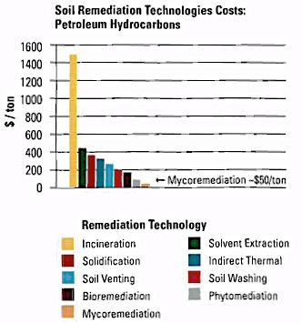
fig 2
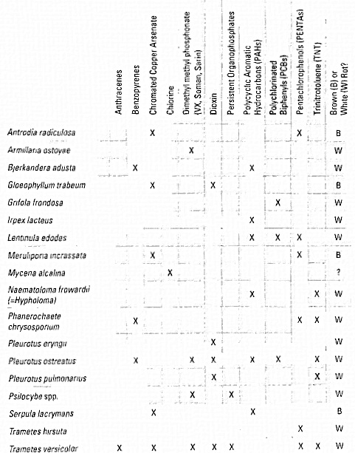fig1

